 | ​ | 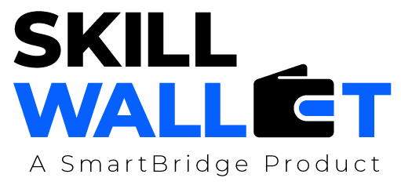
Communication
Date July 7, 2026
Team ID 12344
Project Name Opticrop
Maximum Marks | 1 Mark
Opticrop - Team Communication
Communication Plan:
Role Assignments
Effective communication is essential for a successful project demonstration. This document outlines the Team Lead (A) : milestone planning, review co-ordination
communication strategy used within the team and with stakeholders throughout the project lifecycle, ML Developer (B) : dataset generation, model training, evaluation
including how updates, issues, and feedback were managed. Backend Developer(C): Flask routes, CSV logging, deployment
Frontend / QA (D) : HTML/CSS templates, unit tests, documentation
S.No | Communication Type Communication Chann | Frequency els | Channel / Tool | Participants | Purpose
1 | Team Standup Daily stand-up (15 mi  GitHub pull-request r | n): status sync, b Daily  eviews before me | locker resolution rging to main
2 | Shared task board (G Progress Update | itHub Issues / Pr Weekly | ojects)
3 | Issue / Bug Discussion | As Needed
4 | Stakeholder Review | Bi-Weekly
5 | Final Demo Rehearsal | Once
6
Communication Challenges & Resolutions:
S.No | S.No Challenge Faced | Resolution / Action Taken
1
2
3

